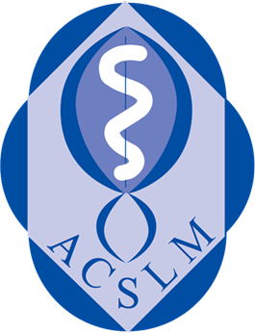 Event booking – how to guide for GUESTS
Academy of Clinical Science and Laboratory Medicine
Book for joint CPD events, or Academy hosted events. www.acslm.ie

- www.acslm.ie, and select the CPD TAB  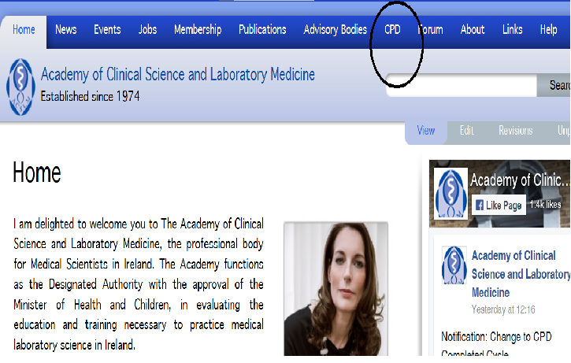  You will be brought into the CPD area where you can book into an event and set up a guest account. | - Click on the word Event  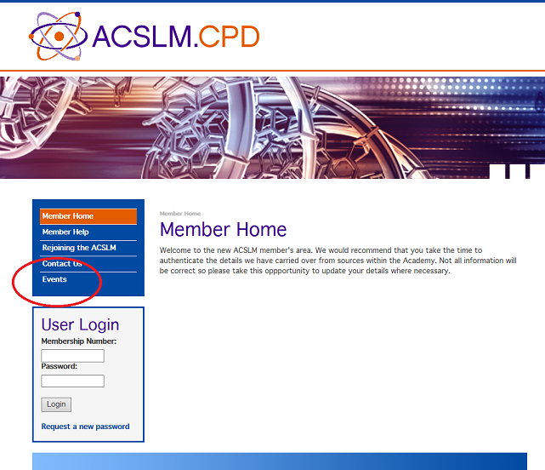  This brings you into the full listing of events available to you.
- Set up a guests account  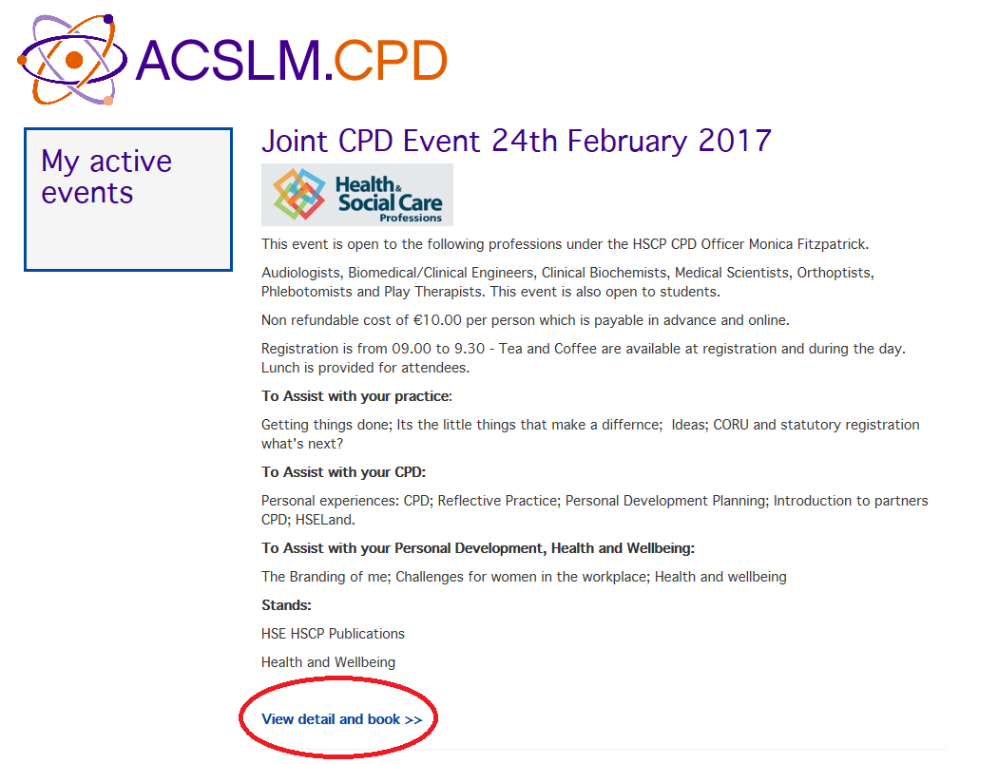  Click on create a non-member account by filling in the details.  A link will be sent to your email address which you can follow to continue your booking. | - Create your booking  Follow the link, click on ‘view details and book’ underneath the event you wish to attend.  - Select ‘Book Now’  - Select ‘Find’ to access your name and membership number  - Slick on ‘select’  - Select ‘Add to my booking’  From now on you have an account and can log, prepay, and pre-book events by using you user name and password.  Forgotten password? Click on request a new password.

